**Cerebral Positron Emission Tomography with Fluorodeoxyglucose - PET scan (see Annex)**

Study of cerebral energy metabolism by positron emission tomography (PET) after injection of 18F-fluorodeoxyglucose (FDG) with attenuation correction calculated by CT, performed with/without sedation.

The global brain metabolism of the patient and 33 control subjects is shown in the appendix - image 1 and 2. There is a decrease in global cortical metabolism of XXX% compared to controls.

Statistical analysis (Statistical Parametric Mapping, SPM12; Bruno et al., 2012) compared the regional distribution of the patient's brain metabolism to a control population.

Hypometabolic regions (in blue) include XXXXXX

Preserved regions (in red) include XXXXXXX

Bruno et al. (2012). Functional neuroanatomy underlying the clinical subcategorization of minimally conscious state patients. Journal of Neurology, 259(6), 1087-1098.

Thibaut et al. (2012). Metabolic activity in external and internal awareness networks in severely brain-damaged patients. Journal of Rehabilitation Medicine, 44(6), 487-94.

Thibaut, Panda et al (2021). Preservation of brain activity in unresponsive patients identifies MCS star. Annals of Neurology, 90(1), 89-100.

**Annex**

**Positron Emission Tomography (PET scan) – Global Metabolism**

Healthy Controls

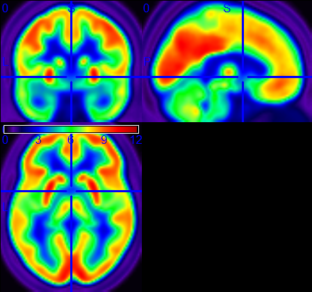

Patient

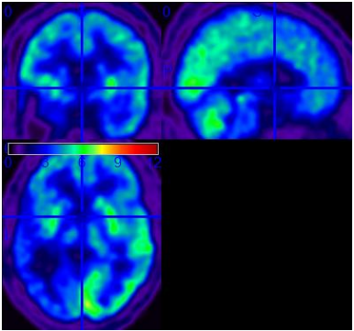



**Regional Brain Metabolism (Statistical Parametric Mapping)**

*Hypometabolic Regions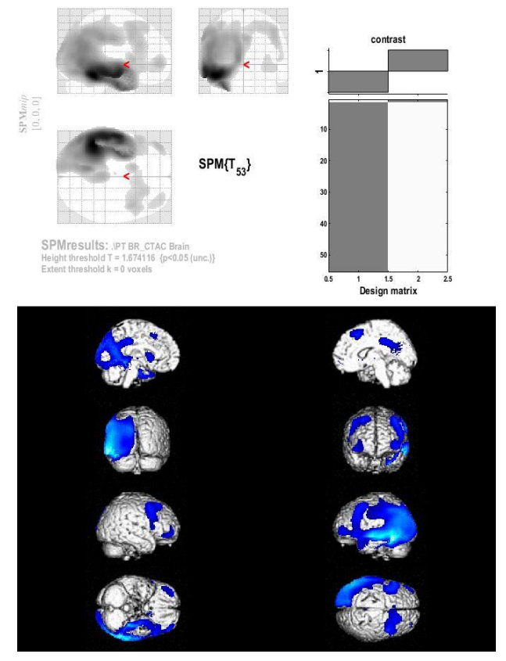*



*Preserved Regions*